# **Security Attacks**

## **Passive Security Attacks 🡪 No modification of Data**

Characteristics

### **The release of message content**

### **Traffic Analysis**

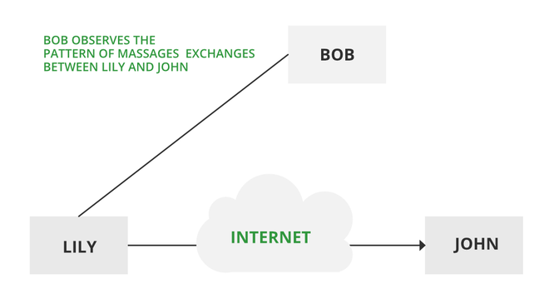

## **Active Security Attacks 🡪 Modification of the Data**

### **Masquerade**

* Sender usually don’t send message.
* But the receiver will receive the message from un-authorized sources in name of the sender.

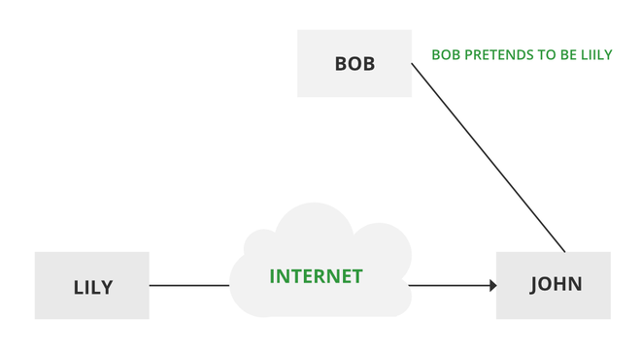

### **Replay**

Captures the message and re-sends it to the Receiver.  
Receiver receives two messages  
1) From the Sender directly.  
2) From the Third-Party (modified) in the sender name.

### **Modification of Message**

### **Denial of Services**

Characteristics

# **Specific Security Mechanism**

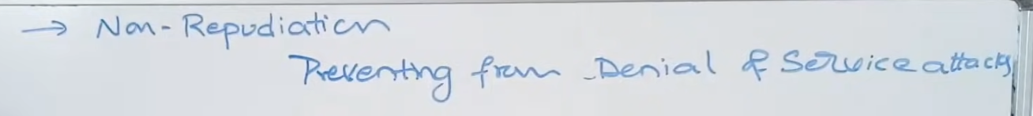

Difference between Authorization and Authentication

# **Pervasive Security Mechanisms**

# **Cryptography types**

**

## **A-symmetric Key Cryptography**

## **Hash function**